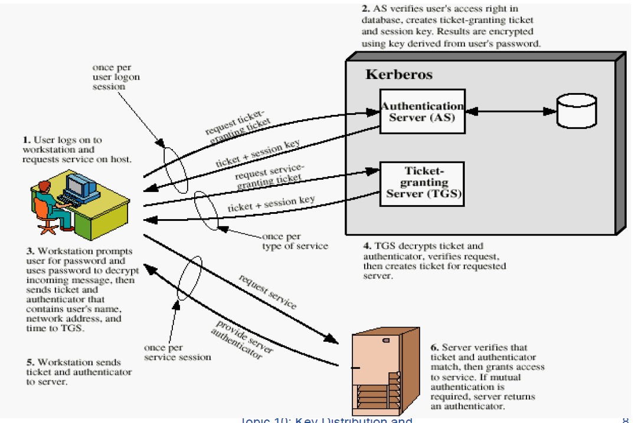

The diagram illustrates the **Kerberos Authentication Protocol**, which is designed to provide secure authentication in a distributed network. Here's a step-by-step explanation:

### **Step 1: User Logs On and Requests Service**

* **Action:**
  + The user logs on to their workstation and requests access to a specific service.
  + The request is sent to the **Authentication Server (AS)**.
* **Details:**
  + The user's credentials (e.g., username) are provided, and a request for a Ticket-Granting Ticket (TGT) is made.
  + This step typically occurs once per user login session.

### **Step 2: Authentication Server Verifies User and Issues TGT**

* **Action:**
  + The AS verifies the user's identity using a shared secret (e.g., a password stored as a hash).
  + If the identity is confirmed, the AS issues two items:
    1. A **Ticket-Granting Ticket (TGT):** Encrypted with the Ticket-Granting Server's (TGS) secret key.
    2. A **Session Key:** Encrypted with the user's secret key (derived from their password).
* **Details:**
  + The TGT is a temporary token that proves the user's identity for future requests.
  + The user’s password is never transmitted directly, enhancing security.

### **Step 3: User Requests Service Access Using TGT**

* **Action:**
  + The workstation prompts the user for their password to decrypt the session key from Step 2.
  + Using the session key, the workstation sends the TGT and an **Authenticator** (a timestamp encrypted with the session key) to the TGS.
* **Details:**
  + The TGT confirms the user’s identity.
  + The Authenticator ensures the request is recent, preventing replay attacks.

### **Step 4: TGS Verifies the TGT and Issues a Service Ticket**

* **Action:**
  + The TGS decrypts the TGT using its secret key and verifies the user’s identity.
  + If valid, it issues two items:
    1. A **Service Ticket:** Encrypted with the target service’s secret key.
    2. A **Session Key:** For secure communication between the user and the requested service.
* **Details:**
  + The TGS ensures the user is authorized to access the requested service.
  + This step occurs once per service type the user requests.

### **Step 5: User Sends Service Ticket to the Requested Server**

* **Action:**
  + The workstation sends the Service Ticket and an Authenticator to the target service server.
* **Details:**
  + The Service Ticket proves the user’s identity and authorization.
  + The Authenticator ensures the freshness of the request.

### **Step 6: Service Server Verifies Ticket and Grants Access**

* **Action:**
  + The service server decrypts the Service Ticket using its secret key and verifies the Authenticator.
  + If both are valid, the server grants the user access to the requested service.
  + For **mutual authentication,** the server may return an authenticator back to the user.
* **Details:**
  + This ensures both the user and server trust each other.

### **Key Features of Kerberos:**

1. **Authentication via TGT:**
   * Users authenticate once and use the TGT for multiple service requests during the session.
2. **Session Keys:**
   * A unique session key is generated for secure communication between parties.
3. **Replay Protection:**
   * Authenticators (with timestamps) prevent replay attacks.
4. **Centralized Trust:**
   * All authentication relies on the AS and TGS, which act as trusted third parties.

This protocol ensures that authentication and session management are secure without transmitting passwords or relying on direct password-based authentication for every service request. Let me know if you need further details!